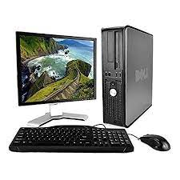

Dell OptiPlex

* Intel Core 2 Duo
* Ram Memory 2 GB
* 80GB Hard Drive
* Screen Size 19 Inches
* **Rs, 31,200**